**BANK LOAN REPORT QUERY**

**KPI’s:**

1. Total Loan Applications

SELECT COUNT(id) AS Total_Loan_Applications FROM financial_loan



1. MTD Loan Applications

SELECT COUNT(id) AS MTD_Loan_Applications FROM financial_loan

WHERE MONTH(issue_date) = 12 and YEAR(issue_date) = 2021



1. PMTD Loan Applications

SELECT COUNT(id) AS PMTD_Loan_Applications FROM financial_loan

WHERE MONTH(issue_date) = 11 and YEAR(issue_date) = 2021



1. Total Funded Amount

SELECT SUM(loan_amount) AS Total_Funded_Amount FROM bank_loan_data



1. MonthToDate(MTD) Total Funded Amount

SELECT SUM(loan_amount) as MTD_Total_Funded_Amount FROM financial_loan

WHERE MONTH(issue_date) = 12 AND YEAR(issue_date) = 2021



1. PMTD Total Funded Amount

SELECT SUM(loan_amount) as MTD_Total_Funded_Amount FROM financial_loan

WHERE MONTH(issue_date) = 11 AND YEAR(issue_date) = 2021



1. Total Amount Received

SELECT SUM(total_payment) as Total_Amount_Received FROM financial_loan



1. MTD Total Amount Received

SELECT SUM(total_payment) as MRD_Total_Amount_Received FROM financial_loan

WHERE MONTH(issue_date) = 12 AND YEAR(issue_date) = 2021



1. PMTD Total Amount Received

SELECT SUM(total_payment) as PMRD_Total_Amount_Received FROM financial_loan

WHERE MONTH(issue_date) = 11 AND YEAR(issue_date) = 2021



1. Average Interest Rate

SELECT AVG(int_rate) AS Average_Interest_Rate FROM financial_loan



1. MTD Average Interest

SELECT AVG(int_rate) AS MTD_Average_Interest_Rate FROM financial_loan

WHERE MONTH(issue_date) = 12



1. PMTD Average Interest

SELECT AVG(int_rate) AS PMTD_Average_Interest_Rate FROM financial_loan

WHERE MONTH(issue_date) = 11



1. Average DTI

SELECT AVG(dti)*100 AS Average_DTI FROM financial_loan



1. MTD Average DTI

SELECT AVG(dti)*100 AS MTD_Average_DTI FROM financial_loan

WHERE MONTH(issue_date) = 12



1. PMTD Average DTI

SELECT AVG(dti)*100 AS PMTD_Average_DTI FROM financial_loan

WHERE MONTH(issue_date) = 11



**GOOD LOAN ISSUED**

1. **Good Loan Percentage**

SELECT (COUNT(CASE WHEN loan_status = 'Fully Paid' OR loan_status = 'Current' THEN id END)*100)/

COUNT(id) AS Good_Loan_Percentage FROM financial_loan



1. **Good Loan Applications**

SELECT COUNT(id) AS Good_Loan_Applications FROM financial_loan

WHERE loan_status = 'Fully Paid' OR loan_status = 'Current'



1. **Good Loan Funded Amount**

SELECT SUM(loan_amount) AS Good_Loan_Funded_Amount FROM financial_loan

WHERE loan_status = 'Fully Paid' OR loan_status = 'Current'



1. **Good Loan Amount Received**

SELECT SUM(total_payment) AS Good_Loan_Amount_Received FROM financial_loan

WHERE loan_status = 'Fully Paid' OR loan_status = 'Current'



**BAD LOAN ISSUED**

1. **Bad Loan Percentage**

SELECT( COUNT(CASE WHEN loan_status = 'Charged Off' THEN id END)*100.0)/

COUNT(id) AS Bad_Loan_Percentage FROM financial_loan



1. **Bad Loan Applications**

SELECT COUNT(id) AS Bad_Loan_Applications FROM financial_loan

WHERE loan_status = 'Charged Off'



1. **Bad Loan Funded Amount**

SELECT SUM(loan_amount) AS Bad_Loan_Funded_Amount FROM financial_loan

WHERE loan_status = 'Charged Off'



1. **Bad Loan Amount Received**

SELECT SUM(total_payment) AS Bad_Loan_Amount_Received FROM financial_loan

WHERE loan_status = 'Charged Off’



1. **LOAN STATUS**

SELECT loan_status,

COUNT(id) AS LOAN_APPLICATIONS,

SUM(loan_amount) AS Total_Funded_Amount ,

SUM(total_payment) AS Total_Amount_Received,

AVG(int_rate) AS Interest_Rate,

AVG(dti)*100 AS DTI

FROM financial_loan

GROUP BY loan_status

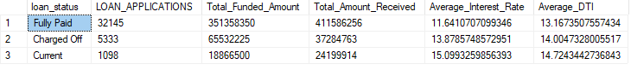

SELECT loan_status,

SUM(loan_amount) As Total_Funded_Amount,

SUM(total_payment) AS Total_Amount_Received

FROM financial_loan

WHERE MONTH(issue_date) = 12

GROUP BY loan_status

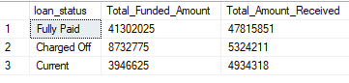

* **BANK LOAN REPORT**

1. **MONTH**

SELECT

MONTH(issue_date) AS MONTH_NUMBER,

DATENAME(MONTH, issue_date) AS MONTH_NAME,

COUNT(id) AS LOAN_APPLICATIONS,

SUM(loan_amount) AS Total_Funded_Amount ,

SUM(total_payment) AS Total_Amount_Received

FROM financial_loan

GROUP BY MONTH(issue_date) , DATENAME(MONTH, issue_date)

ORDER BY MONTH(issue_date)

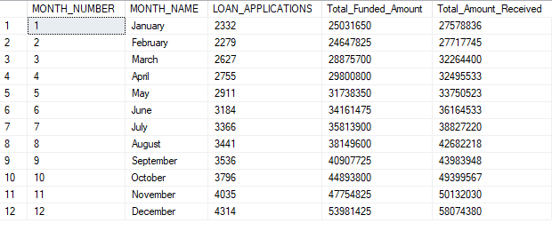

1. **TERM**

SELECT

term AS TERM,

COUNT(id) AS LOAN_APPLICATIONS,

SUM(loan_amount) AS Total_Funded_Amount ,

SUM(total_payment) AS Total_Amount_Received

FROM financial_loan

GROUP BY term

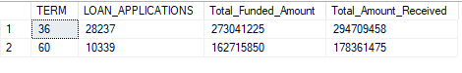

1. **STATE**

SELECT

address_state AS STATE,

COUNT(id) AS LOAN_APPLICATIONS,

SUM(loan_amount) AS Total_Funded_Amount ,

SUM(total_payment) AS Total_Amount_Received

FROM financial_loan

GROUP BY address_state

ORDER BY address_state

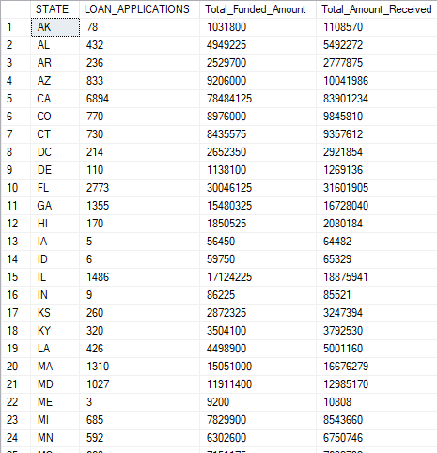

1. **EMPLOYEE LENGTH**

SELECT

emp_length AS EMPLOYEE_LENGTH,

COUNT(id) AS LOAN_APPLICATIONS,

SUM(loan_amount) AS Total_Funded_Amount ,

SUM(total_payment) AS Total_Amount_Received

FROM financial_loan

GROUP BY emp_length

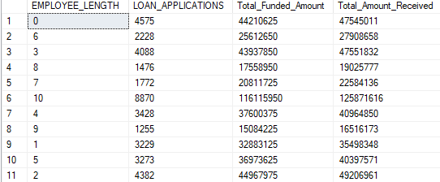

1. **PURPOSE**

SELECT

purpose AS PURPOSE,

COUNT(id) AS LOAN_APPLICATIONS,

SUM(loan_amount) AS Total_Funded_Amount ,

SUM(total_payment) AS Total_Amount_Received

FROM financial_loan

GROUP BY purpose

ORDER BY purpose

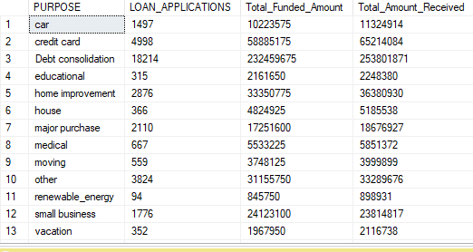

1. **HOME OWNERSHIP**

SELECT

home_ownership AS HOME_OWNERSHIP,

COUNT(id) AS LOAN_APPLICATIONS,

SUM(loan_amount) AS Total_Funded_Amount ,

SUM(total_payment) AS Total_Amount_Received

FROM financial_loan

GROUP BY home_ownership

ORDER BY home_ownership

